

User Acceptance Test (UAT) Plan

Cloud-based Bioinformatics Tools

Pedigree

Document Version: 1.1

Date: 28/11/2013

Contents

1 Document Management 3
1.1 Contributors 3
1.2 Version Control 3
2 USER ACCEPTANCE TESTING 4
2.1 User Acceptance Definition 4
2.2 UAT Responsibilities 4
3 UAT STRATEGY 5
3.1 Test Approach 5
3.2 Assumptions & Constraints 5
3.3 Test Scenarios 5
4 USER TESTING 6
5 UAT RESULTS 7
5.1 Open Issues 7
5.2 Document Sign Off 7

Document Management

Contributors

Role | Group | Name
Owner | The Ark | Travis Endersby, Adrian Bickerstaffe, John Hopper
Developer | The Ark | Thilina Ranawera
Tester/  User | The Centre of Epidemiology and Biostatistics, The University of Melbourne | Adrian Bickerstaffe

Version Control

Date | Version | Author | Section | Amendment
26/11/2013 | 1.0 | Travis Endersby |  | Initial Version
28/11/2013 | 1.1 | Adrian Bickerstaffe |  | Minor edits to organisational names.

USER ACCEPTANCE TESTING

User Acceptance Definition

User Acceptance Testing should ensure that the application performs at an acceptable level for the Customer.

UAT Responsibilities

Role | Name | Responsibilities
Project Manager | Paul White, Travis Endersby | Communication with users to agree format and scope of UAT  Agree acceptance criteria with the Steering Committee nominee and designated UAT test personnel prior to commencing UAT  Ensure that a detailed test plan is available for test users  Ensure that bugs identified during UAT are logged in the Jira Issues Log  Ensure testing takes place within agreed timeframes
Steering Committee Nominee | John Hopper | Ensure appropriate UAT personnel to conduct testing are identified and available  Signoff final test results
UAT Tester and Business analyst | Adrian Bickerstaffe | Conduct UAT tests

UAT STRATEGY

The User Acceptance Test Plan should be used to record the Steering Committee Nominee(s) sign off of the documented scenarios. It is recommended that detailed test plans be used to record the results of user testing.

Test Approach
The purpose of this test case is to validate the Pedigree module.

Assumptions & Constraints
The following is assumed:
- The test user can successfully access an UAT environment & production environment
- The test user has a valid login to The Ark
- The test user has been granted access to the all appropriate modules to cross check data and Reporting Module to modify and submit Pedigrees
- There is production data is available

Test Scenarios
Test Scenarios are laid out in the attached document (a scanned condensed 20 page print out for sign off and the original document with all of the previous test runs and communications will be available as an xls spreadsheet).

USER TESTING

PLEASE SEE ATTACHED DOCUMENTS

Any failed issues identified during UAT should be added to The Ark Issues Log in Jira. It may be agreed that UAT can be signed off while some feature requests remain – please add the Jira reference to the appropriate section above if this is the case.

The following requests have been made for a future release. These issues are low priority and all parties are willing to sign off on the condition that these issues are addressed by 31/12/2013.

https://the-ark.atlassian.net/browse/ARK-1122
- Cycles in pedigree structures should be detected and reported.

https://the-ark.atlassian.net/browse/ARK-1123

Extra validation for TwinStatus and TwinUID fields during upload

UAT RESULTS

Open Issues

Please insert a copy of any open issues from Jira, together with details of why these issues remain open at the sign off of the Acceptance Stage.

No issues were found which caused the delay of acceptance / sign-off, however there are several feature requests specified in the attached document. These will be prioritized and, if valued highly enough, delivered after consultation with Adrian Bickerstaffe and other parties. They are not critical to the current use of the application.

Document Sign Off

Role | Name | Signature | Date
UAT Test Manager | Adrian Bickerstaffe | 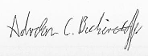 | 28/11/2013
Steering Committee Nominee | John Hopper | 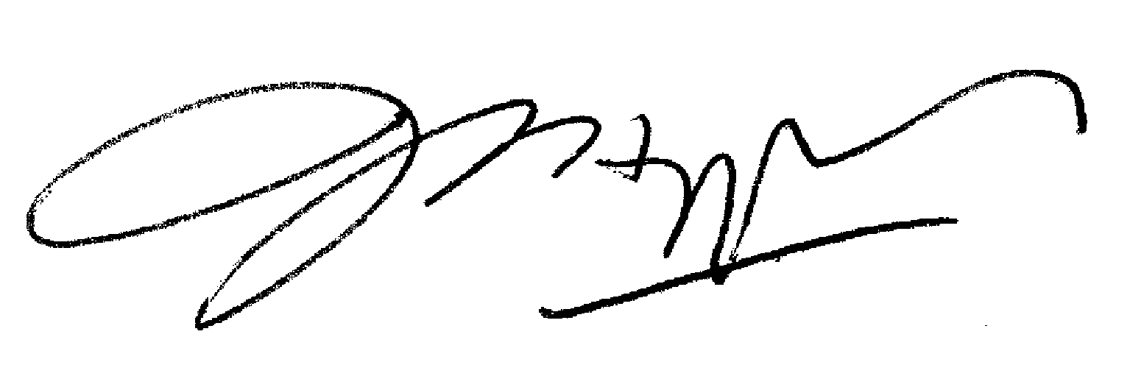 | 28/11/2013

APPENDIX A: Attached test results (following pages);

